**05AgiSoft Photoscan Pipeline**

1. Open a new project and save it named by the date (mmddyyyy) in the computer folder 2019 Agisoft Projects
2. Import images for flight reconstruction by clicking on  icon in the *Workspace* panel.
3. Align Images {*will take around 2 hrs}*
   1. Go on top bar to Workflow > Align Photos and put the following parameters.

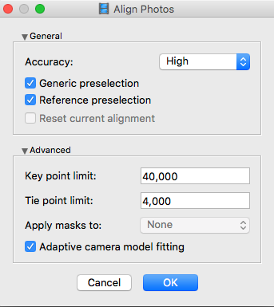

* 1. Click OK button to start alignment.

1. Assign GCP markers
   1. Double click on image from the bottom pane with a GCP present to view it.
   2. Zoom in to locate the GCP.
   3. Place marker on the middle point by clicking  *Add Marker* command form the photo context menu available on right-click.
   4. Filter images in *Photos* pane using page7image2991483616 *Filter Photos by Markers* option in the context menu available by right-clicking on the marker point in the image or the marker name in reference panel.

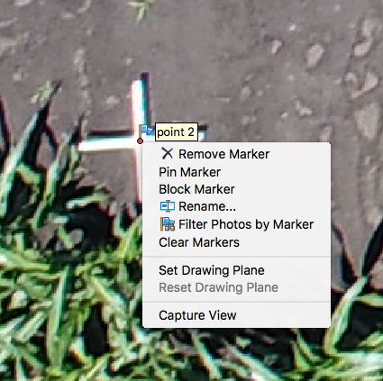

* 1. Check the marker location on every related photo and refine its position if necessary to provide maximum accuracy. Open each photo where the created marker is visible. Zoom in and drag the marker to the correct location while holding left mouse button.
  2. Remove marker photo filter by clicking on ** *Reset Filter* command on the *Photos* pane. Repeat the described step for every GCP.
  3. Rename GCPs according to map (Red1, Red2, Red3, Red4, Orange1, Orange2, Ground1, Ground2, Ground3, Ground4, Ground5, Ground6, WeatherStation)
  4. Import marker coordinates from file indicate din drive. Click page8image2994511632*Import* button on the *Reference* pane toolbar and select file containing GCP coordinates data in the *Open* dialog (GCP Coordinates mmddyyyy.csv). The easiest way is to load simple character-separated file (*.csv) that contain markers name, x-, y- coordinates and height.
  5. In *Import CSV* dialog indicate the delimiter according to the structure of the file and select the row to start loading from. Note that # character indicates a commented line that is not counted while numbering the rows. Indicate for the program what parameter is specified in each column through setting correct column numbers in the *Columns* section of the dialog. Also it is recommended to specify valid coordinate system in the corresponding field for the values used for camera center data.

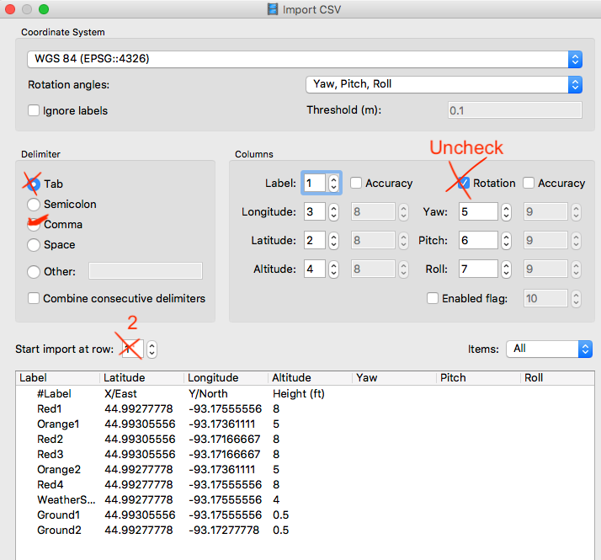

* 1. Click page9image2994659296*Optimize* button on the *Reference* pane toolbar to optimize camera positions.

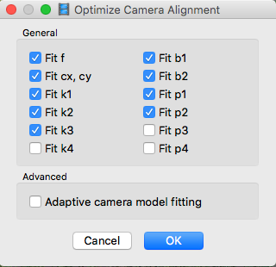 Check Fit k4 box as well

1. Build Dense Point Cloud { *will take around 2 days}*
   1. Workflow > Build Dense Cloud
      1. Quality: **High**
      2. Depth filtering: **Moderate**
      3. Calculate point colors should be checked
2. Build DEM (from dense point cloud)
   1. Workflow > Build DEM

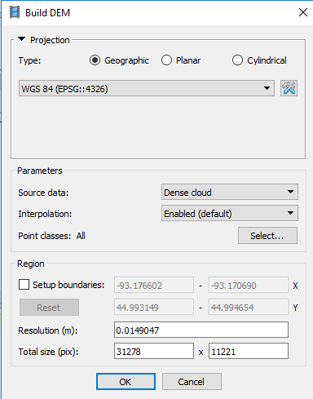

1. Build orthomosaic (based on DEM)
   1. Workflow > Build Orthomosaic

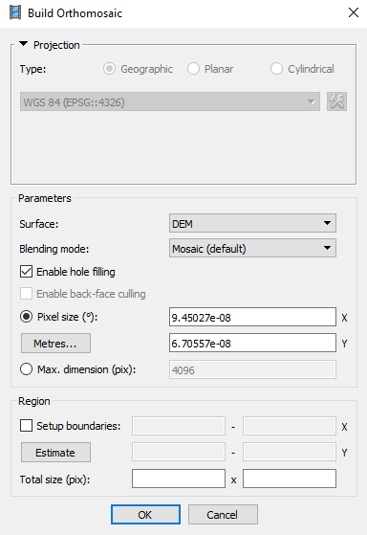

1. Export data
   1. Export Dense Cloud in ply format
      1. Right click on Dense Cloud in the *Workspace* panel and click *Export Dense Cloud*
      2. Save as: date_pointcloud.ply (ex. 07022018_pointcloud.ply) in the folder

LAB-Springer/Sara_T/Photoscan Projects/2019/*field*/Agisoft Projects/PointCloud

* 1. Export DEM following same procedure as dense cloud
     1. Export as Tif format
     2. Check box write big tiff files aside from any default parameters
     3. Save as: date_DEM.tif in folder

LAB-Springer/Sara_T/Photoscan Projects/2019/*field*/Agisoft Projects/DEM

* 1. Export orthomosaic following same procedure
     1. Export as Tif format
     2. Save as: date_ortho.tif in folder

LAB-Springer/Sara_T/Photoscan Projects/2019/*field*/Agisoft Projects/Ortho

1. ***** IMPORTANT Save project file again named by the date (mmddyyyy) in the computer folder 2019 Agisoft Projects once done! This will take a couple of minutes to save. Save a copy also in lab server under LAB-Springer/Sara_T/Photoscan Projects/2019/*field*/Agisoft Projects/
2. Update google drive file [DataCollectionSummary_2019](https://docs.google.com/spreadsheets/d/1xIPF0DQcKusztKYgOU1PcwpE1JDWymJnWCQrKpriODA/edit?usp=sharing) (first sheet: 2019_Summary) indicating date for which DEM/ortho/pointcloud was saved
3. Update [DataCollectionSummary_2019](https://docs.google.com/spreadsheets/d/1xIPF0DQcKusztKYgOU1PcwpE1JDWymJnWCQrKpriODA/edit?usp=sharing) google doc (second sheet: Reconstruction Summary) with reconstruction information available in the workspace